PROJECT TITLE:

Interactive digital portfolio using front end development

no change in this slide   
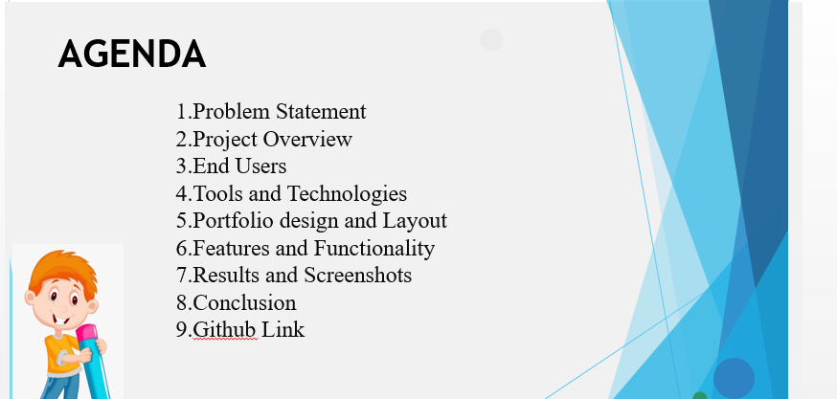

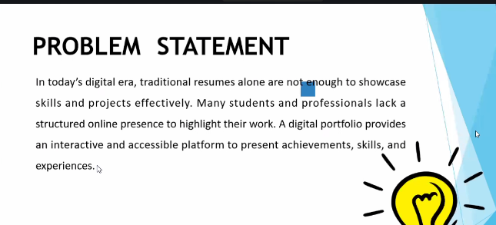

**different project problem statements** for your **Digital Portfolio** project.

1. Many students lack a professional space to present their skills and achievements. A digital portfolio enables organized showcasing of academic and technical milestones.
2. Traditional resumes are limited and static, making it hard to convey creativity and real-world skills. A digital portfolio brings interactivity and personalization.
3. Recruiters often overlook talented candidates due to poor online presence. A personal portfolio website solves this by offering a centralized, visually appealing profile.
4. Students find it difficult to compile and present their certificates and projects effectively. A digital portfolio creates a structured platform for easy access.
5. In the digital age, job seekers need more than a resume. A responsive portfolio offers proof of skills through live projects, visual layouts, and accessible contact details.
6. Lack of an online presence can limit academic or career opportunities. A digital portfolio empowers users to showcase their abilities in a modern, professional way.
7. Many professionals rely on outdated CVs that don’t reflect their actual capabilities. A digital portfolio allows real-time updates and links to active work.
8. There’s no efficient way for students to demonstrate technical growth over time. A portfolio site helps track, share, and display progress in one place.
9. Certificates and project files often get lost in emails or folders. A digital portfolio stores and organizes these documents for quick reference.
10. Students often struggle during interviews to visually present their work. A portfolio site offers a visual storytelling tool to strengthen personal branding.
11. In an increasingly visual and web-driven world, plain resumes fall short. A portfolio website combines text, media, and design to enhance self-presentation.
12. Sharing achievements via PDF resumes is limiting. A digital portfolio allows students to share a personalized link with interactive content.
13. A lack of technical visibility hinders students from standing out. A modern portfolio site gives them a competitive edge in the job and academic markets.
14. Employers value real work over words. A portfolio site allows students to embed live demos, GitHub links, and more to showcase actual projects.
15. Students often forget or misplace project records. A portfolio website serves as a personal archive, keeping everything accessible in one place.
16. Generic LinkedIn profiles are not enough to showcase individuality. A personal portfolio gives students creative freedom to present themselves uniquely.
17. Many students do not have a professional online identity. A digital portfolio builds that identity, acting as a digital business card.
18. Traditional resumes do not capture hands-on experience well. A portfolio website can demonstrate learning journeys through visuals, timelines, and examples.
19. Students often feel underprepared when applying for internships or jobs. A digital portfolio boosts confidence by professionally presenting their work.
20. A well-crafted portfolio can open doors, but building one can be challenging. This project aims to simplify that process with a responsive, customizable website.

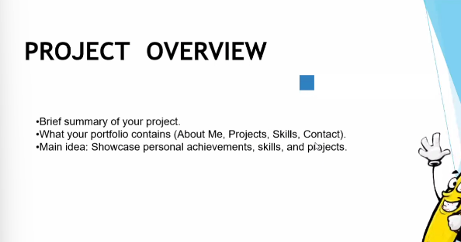

### **✅ Variation 1:**

This project involves the development of a modern and responsive digital portfolio designed to help individuals showcase their academic, professional, and technical achievements. The portfolio includes key sections such as "About Me", "Education", "Skills", "Certificates", and a "Contact" form for easy communication. The main goal is to provide a personalized online space that highlights the user’s strengths and experiences through an interactive and visually appealing interface.

### **✅ Variation 2:**

* **Project Summary:** A responsive digital portfolio website created to serve as a personal showcase platform.
* **Includes:**
  + About Me
  + Education
  + Skills
  + Certificates
  + Contact Form
* **Main Objective:** To effectively present personal achievements, technical skills, and projects in a structured and accessible format.

### **✅ Variation 3:**

This project is a personal digital portfolio website aimed at enhancing professional presence online. It allows users to display their career highlights, academic background, and certifications in an organized manner. Built with a focus on responsiveness and user experience, the portfolio serves as a central hub for self-promotion.

**Key Features:**

* **About Me:** Introduction and background
* **Education:** Academic history and milestones
* **Skills:** Technical and soft skills
* **Certificates:** Achievements and completed courses
* **Contact:** Simple form for communication or queries

### **✅ Variation 4:**

In an age where first impressions are often digital, a personal portfolio website bridges the gap between a resume and a real-world introduction. This project is designed to serve as a digital identity — a dynamic space where visitors can learn about who am , what I’ve accomplished, and how to reach out.

* A warm **About Me** section
* Clear **Education** and **Skills** listings
* Verified **Certificates**
* A working **Contact Form**

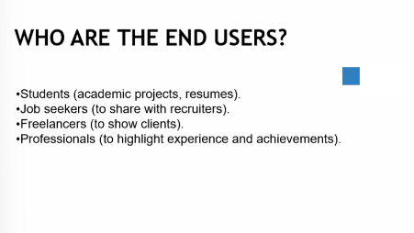

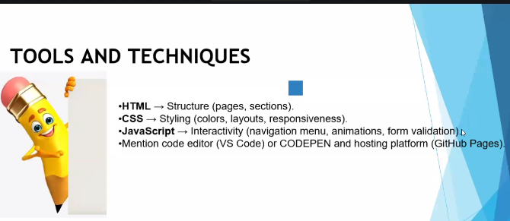

JavaScript → Interactivity (mobile navigation menu toggle)

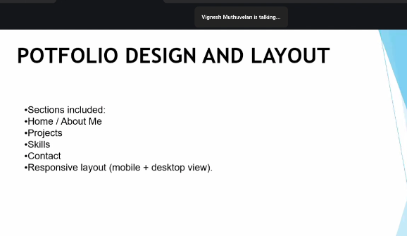

**PORTFOLIO DESIGN AND LAYOUT**

• Home

• About Me

• Skills

• Projects

• Achievements

• Contact

• Responsive navigation with hamburger menu

•Responsive layout (mobile ,desktop view)

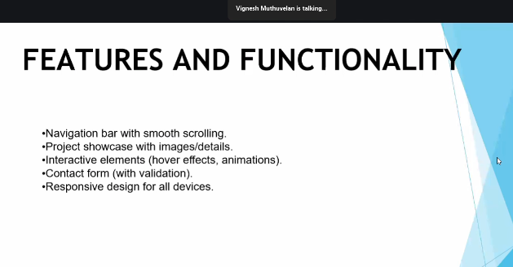

• Responsive navigation bar with hamburger menu for mobile view

• Skills section displayed using simple list

•Certificates section displayed in grid format

• Contact details with email,-phone number

• Footer copyright  
  
  
  
Results and ss   
  
Desktop view   
Mobile view - 760px X 633px

1. 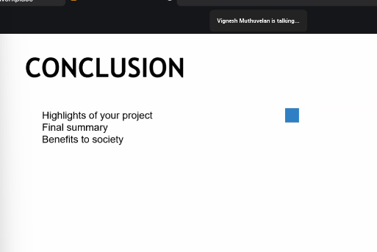

This portfolio project highlights my journey as a B.Sc. Computer Science student. It showcases my interests, skills, and projects in a clean, responsive layout. The site is simple, beginner-friendly, and functional across desktop and mobile.

The project demonstrates a personal portfolio with sections like Home, About Me, Skills, Projects, and Contact. Its responsive design and interactive menu ensure smooth navigation. It reflects both creativity and technical growth.

This portfolio represents my academic and creative interests. It features a clear layout with structured sections, making it accessible on all devices. The project is beginner-focused yet complete.

The portfolio project serves as a digital space to present my background, skills, and hobbies. With responsive design and simple interactivity, it works across platforms while staying easy to use.

This project is a beginner-friendly portfolio website that includes essential sections such as About, Skills, Projects, and Contact. Its responsive structure and simple JavaScript add interactivity without complexity.

The portfolio highlights my profile as a Computer Science student with an interest in fashion design. It includes key sections, a responsive layout, and a functional navigation menu.

This project combines simplicity with usability. It organizes information into sections like About, Skills, and Projects while ensuring responsive design and basic interactivity through JavaScript.

The portfolio demonstrates how a structured layout can showcase both academic and personal interests. It provides easy navigation, responsive viewing, and a clean user experience.

This beginner-level portfolio project displays my skills and hobbies in a structured manner. It emphasizes responsive design, smooth navigation, and practical usability.

The project offers a concise digital presence with organized sections and responsive functionality. It reflects both technical learning and creative interests while being simple and effective.